5.

(a)

优点: 压缩效率可提高5~10%; 不必使用码表; 自适应算术编码能够根据已经编码的信息串来调整当前符号的概率估计, 从而更有效的编码.

缺点: 硬件实现稍复杂; 通信过程中查错会扩散.

(b)

i. BBB的Huffman编码为101010, 需要6 bits.

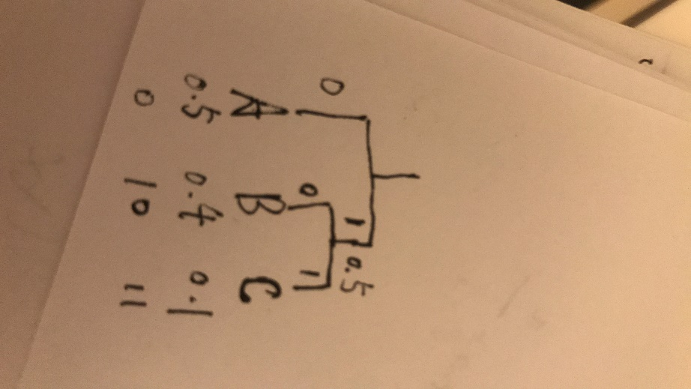

ii. BBB的算术码为1101, 需要4 bits.

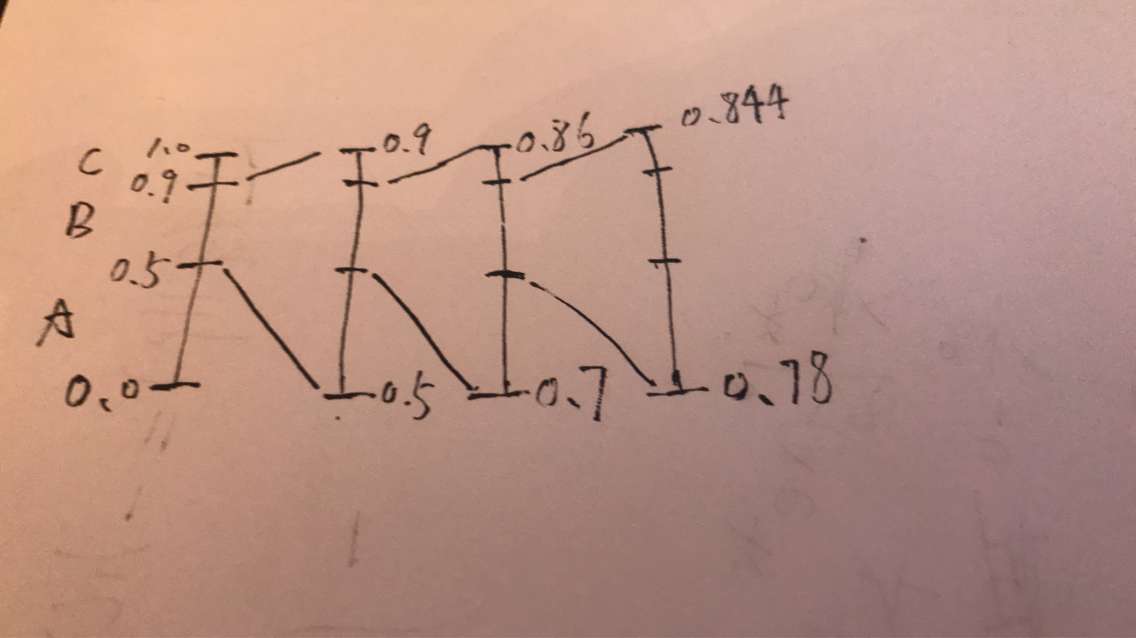

8.

输入: 0110011

码表:

|  |  |  |  |  |  |  |
| --- | --- | --- | --- | --- | --- | --- |
| 0 | 1 | 01 | 11 | 10 | 00 | 011 |
| 1 | 2 | 3 | 4 | 5 | 6 | 7 |

输出:

|  |  |  |  |  |  |
| --- | --- | --- | --- | --- | --- |
| 0 | 1 | 1 | 0 | 01 | 1 |
| 1 | 2 | 2 | 1 | 3 | 2 |